**Spring Core_Maven**

**Exercise 1: Configuring a Basic Spring Application**

src/main/java/

└── com/

└── example/

└── library/

├── BookRepository.java

├── BookService.java

└── LibraryManagementApplication.java

src/main/resources/

└── applicationContext.xml

**pom.xml**

dependencies>

<!-- Spring Core & Context -->

<dependency>

<groupId>org.springframework</groupId>

<artifactId>spring-context</artifactId>

<version>5.3.30</version>

</dependency>

</dependencies>

**BookRepository.java**

package com.example.LibraryManagement;

public class BookRepository {

public void displayBooks() {

System.*out*.println("Displaying list of books from repository...");

}

}

**BookService.java**

package com.example.LibraryManagement;

public class BookService {

private BookRepository bookRepository;

public void setBookRepository(BookRepository bookRepository) {

this.bookRepository = bookRepository;

}

public void listBooks() {

System.*out*.println("BookService: Calling repository...");

bookRepository.displayBooks();

}

}

**LibraryManagementApplication.java**

package com.example.LibraryManagement;

import org.springframework.context.ApplicationContext;

importorg.springframework.context.support.ClassPathXmlApplicationContext;

public class LibraryManagementApplication {

public static void main(String[] args) {

ApplicationContext context = new ClassPathXmlApplicationContext("applicationContext.xml");

BookService service = context.getBean("bookService", BookService.class);

service.listBooks();

}

}

**applicationContext.xml**

<?xml version=*"1.0"* encoding=*"UTF-8"*?>

<beans xmlns=*"http://www.springframework.org/schema/beans"*

xmlns:xsi=*"http://www.w3.org/2001/XMLSchema-instance"*

xsi:schemaLocation=*"*

*http://www.springframework.org/schema/beans*

*https://www.springframework.org/schema/beans/spring-beans.xsd"*>

<!-- Define the BookRepository bean -->

<bean id=*"bookRepository"* class=*"com.example.LibraryManagement.BookRepository"* />

<!-- Define the BookService bean and inject BookRepository via setter -->

<bean id=*"bookService"* class=*"com.example.LibraryManagement.BookService"*>

<property name=*"bookRepository"* ref=*"bookRepository"* />

</bean>

</beans>

**Output:**

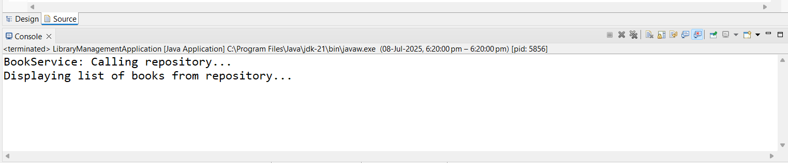

**Exercise 2: Implementing Dependency Injection**

src/main/java/

└── com/

└── example/

└── library/

├── BookRepository.java

├── BookService.java

└── LibraryManagementApplication.java

src/main/resources/

└── applicationContext.xml

**pom.xml**

dependencies>

<!-- Spring Core & Context -->

<dependency>

<groupId>org.springframework</groupId>

<artifactId>spring-context</artifactId>

<version>5.3.30</version>

</dependency>

</dependencies>

**BookRepository.java**

package com.example.LibraryManagement;

public class BookRepository {

public void displayBooks() {

System.*out*.println("Displaying list of books from repository...");

}

}

**BookService.java**

package com.example.LibraryManagement;

public class BookService {

private BookRepository bookRepository;

public void setBookRepository(BookRepository bookRepository) {

this.bookRepository = bookRepository;

}

public void listBooks() {

System.*out*.println("BookService: Calling repository...");

bookRepository.displayBooks();

}

}

**LibraryManagementApplication.java**

package com.example.LibraryManagement;

import org.springframework.context.ApplicationContext;

importorg.springframework.context.support.ClassPathXmlApplicationContext;

public class LibraryManagementApplication {

public static void main(String[] args) {

ApplicationContext context = new ClassPathXmlApplicationContext("applicationContext.xml");

BookService service = context.getBean("bookService", BookService.class);

service.listBooks();

}

}

**applicationContext.xml**

<?xml version=*"1.0"* encoding=*"UTF-8"*?>

<beans xmlns=*"http://www.springframework.org/schema/beans"*

xmlns:xsi=*"http://www.w3.org/2001/XMLSchema-instance"*

xsi:schemaLocation=*"*

*http://www.springframework.org/schema/beans*

*https://www.springframework.org/schema/beans/spring-beans.xsd"*>

<!-- Define the BookRepository bean -->

<bean id=*"bookRepository"* class=*"com.example.LibraryManagement.BookRepository"* />

<!-- Define the BookService bean and inject BookRepository via setter -->

<bean id=*"bookService"* class=*"com.example.LibraryManagement.BookService"*>

<property name=*"bookRepository"* ref=*"bookRepository"* />

</bean>

</beans>

**Output:**



**Exercise 4: Creating and Configuring a Maven Project (LibraryManagement)**

**Update pom.xml :**

<project xmlns="http://maven.apache.org/POM/4.0.0" xmlns:xsi="http://www.w3.org/2001/XMLSchema-instance"

xsi:schemaLocation="http://maven.apache.org/POM/4.0.0 http://maven.apache.org/xsd/maven-4.0.0.xsd">

<modelVersion>4.0.0</modelVersion>

<groupId>com.example</groupId>

<artifactId>LibraryManagement</artifactId>

<version>0.0.1-SNAPSHOT</version>

<packaging>jar</packaging>

<name>LibraryManagement</name>

<url>http://maven.apache.org</url>

<properties>

<project.build.sourceEncoding>UTF8

</project.build.sourceEncoding>

</properties>

<build>

<plugins>

<plugin>

<groupId>org.apache.maven.plugins</groupId>

<artifactId>maven-compiler-plugin</artifactId>

<version>3.8.1</version>

<configuration>

<source>1.8</source>

<target>1.8</target>

</configuration>

</plugin>

</plugins>

</build>

<dependencies>

<dependency>

<groupId>org.springframework</groupId>

<artifactId>spring-context</artifactId>

<version>5.3.30</version>

</dependency>

<dependency>

<groupId>org.springframework</groupId>

<artifactId>spring-aop</artifactId>

<version>5.3.30</version>

</dependency>

<dependency>

<groupId>org.springframework</groupId>

<artifactId>spring-webmvc</artifactId>

<version>5.3.30</version>

</dependency>

</dependencies>

</project>

**Output:**



**Spring Data JPA with Spring Boot, Hibernate**

**Exercise 1: Spring Data JPA - Quick Example**

**OrmLearnApplication.java**

**package** com.cognizant.orm_learn;

**import** java.util.List;

**import** org.slf4j.Logger;

**import** org.slf4j.LoggerFactory;

**import** org.springframework.boot.SpringApplication;

**import** org.springframework.boot.autoconfigure.SpringBootApplication;

**import** org.springframework.context.ApplicationContext;

**import** com.cognizant.orm_learn.model.Country;

**import** com.cognizant.orm_learn.service.CountryService;

@SpringBootApplication

**public** **class** OrmLearnApplication {

**private** **static** **final** Logger ***LOGGER*** = LoggerFactory.*getLogger*(OrmLearnApplication.**class**);

**private** **static** CountryService *countryService*;

**public** **static** **void** main(String[] args) {

ApplicationContext context = SpringApplication.*run*(OrmLearnApplication.**class**, args);

*countryService* = context.getBean(CountryService.**class**);

***LOGGER***.info("Inside main");

*testGetAllCountries*();

}

**private** **static** **void** testGetAllCountries() {

***LOGGER***.info("Start");

List<Country> countries = *countryService*.getAllCountries();

***LOGGER***.debug("countries={}", countries);

***LOGGER***.info("End");

}

}

**Country.java**

**package** com.cognizant.orm_learn.model;

**import** jakarta.persistence.*;

@Entity

@Table(name = "country")

**public** **class** Country {

@Id

@Column(name = "code")

**private** String code;

@Column(name = "name")

**private** String name;

// Getters and Setters

**public** String getCode() { **return** code; }

**public** **void** setCode(String code) { **this**.code = code; }

**public** String getName() { **return** name; }

**public** **void** setName(String name) { **this**.name = name; }

@Override

**public** String toString() {

**return** "Country [code=" + code + ", name=" + name + "]";

}

}

**CountryRepository.java**

**package** com.cognizant.orm_learn.repository;

**import** org.springframework.data.jpa.repository.JpaRepository;

**import** org.springframework.stereotype.Repository;

**import** com.cognizant.orm_learn.model.Country;

@Repository

**public** **interface** CountryRepository **extends** JpaRepository<Country, String> {

}

**CountryService.java**

**package** com.cognizant.orm_learn.service;

**import** java.util.List;

**import** org.springframework.beans.factory.annotation.Autowired;

**import** org.springframework.stereotype.Service;

**import** org.springframework.transaction.annotation.Transactional;

**import** com.cognizant.orm_learn.model.Country;

**import** com.cognizant.orm_learn.repository.CountryRepository;

@Service

**public** **class** CountryService {

@Autowired

**private** CountryRepository countryRepository;

@Transactional

**public** List<Country> getAllCountries() {

**return** countryRepository.findAll();

}

}

**Pom.xml**

<project xmlns="http://maven.apache.org/POM/4.0.0"

xmlns:xsi="http://www.w3.org/2001/XMLSchema-instance"

xsi:schemaLocation="http://maven.apache.org/POM/4.0.0

http://maven.apache.org/xsd/maven-4.0.0.xsd">

<modelVersion>4.0.0</modelVersion>

<groupId>com.cognizant</groupId>

<artifactId>orm-learn</artifactId>

<version>0.0.1-SNAPSHOT</version>

<packaging>jar</packaging>

<name>orm-learn</name>

<description>Demo project for Spring Boot and JPA</description>

<parent>

<groupId>org.springframework.boot</groupId>

<artifactId>spring-boot-starter-parent</artifactId>

<version>3.2.5</version>

<relativePath/>

</parent>

<properties>

<java.version>21</java.version>

</properties>

<dependencies>

<!-- Spring Boot Starter Web -->

<dependency>

<groupId>org.springframework.boot</groupId>

<artifactId>spring-boot-starter-web</artifactId>

</dependency>

<!-- Spring Data JPA -->

<dependency>

<groupId>org.springframework.boot</groupId>

<artifactId>spring-boot-starter-data-jpa</artifactId>

</dependency>

<!-- MySQL Driver -->

<dependency>

<groupId>com.mysql</groupId>

<artifactId>mysql-connector-j</artifactId>

<scope>runtime</scope>

</dependency>

<!-- Spring Boot DevTools (Optional) -->

<dependency>

<groupId>org.springframework.boot</groupId>

<artifactId>spring-boot-devtools</artifactId>

<scope>runtime</scope>

</dependency>

<!-- JUnit 5 and Spring Test -->

<dependency>

<groupId>org.springframework.boot</groupId>

<artifactId>spring-boot-starter-test</artifactId>

<scope>test</scope>

</dependency>

</dependencies>

<build>

<plugins>

<plugin>

<groupId>org.apache.maven.plugins</groupId>

<artifactId>maven-compiler-plugin</artifactId>

<version>3.10.1</version>

<configuration>

<release>${java.version}</release>

</configuration>

</plugin>

</plugins>

</build>

</project>

**application.properties**

spring.application.name=orm-learn

# Logging

logging.level.org.springframework=info

logging.level.com.cognizant=debug

logging.level.org.hibernate.SQL=trace

logging.level.org.hibernate.type.descriptor.sql=trace

logging.pattern.console=%d{dd-MM-yy} %d{HH:mm:ss.SSS} %-20.20thread %5p %-25.25logger**{25}** %25M %4L %m%n

# DB Connection

# ===============================

# = DATABASE CONFIGURATION =

# ===============================

spring.datasource.url=jdbc:mysql://localhost:3306/ormlearn

spring.datasource.username=root

spring.datasource.password=root

spring.datasource.driver-class-name=com.mysql.cj.jdbc.Driver

# ===============================

# = JPA & HIBERNATE =

# ===============================

spring.jpa.hibernate.ddl-auto=none

spring.jpa.show-sql=true

spring.jpa.properties.hibernate.dialect=org.hibernate.dialect.MySQL8Dialect

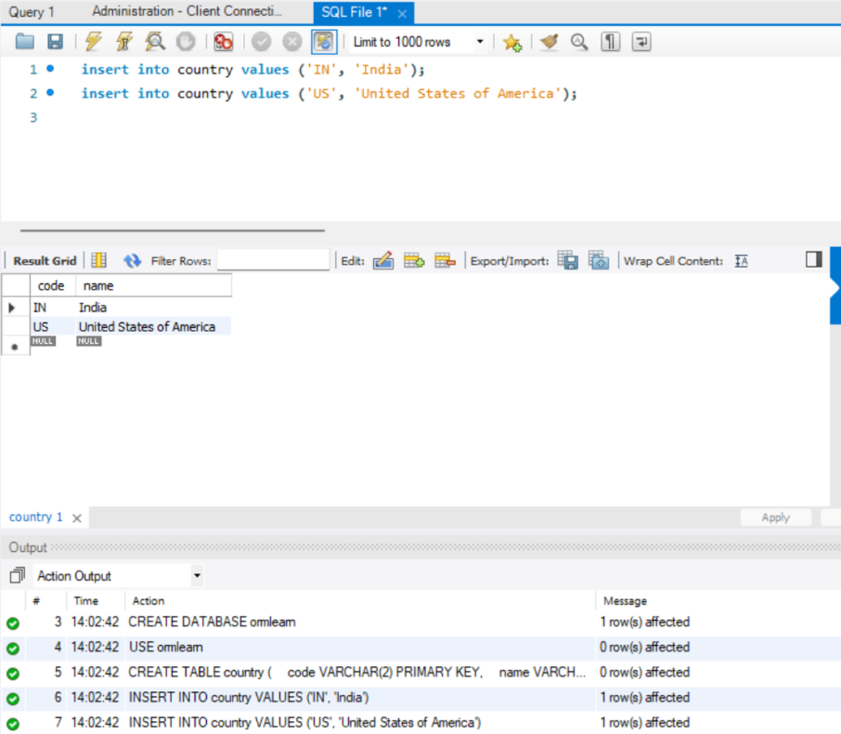

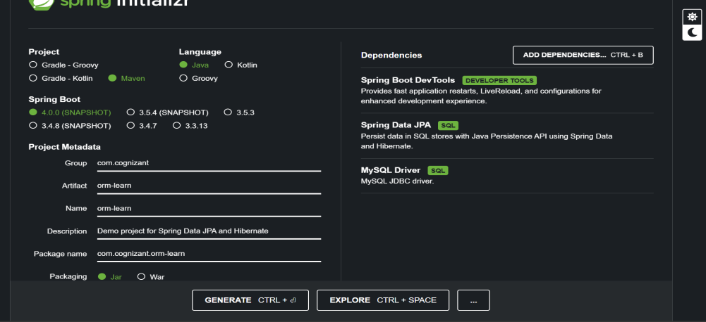

**Output:**

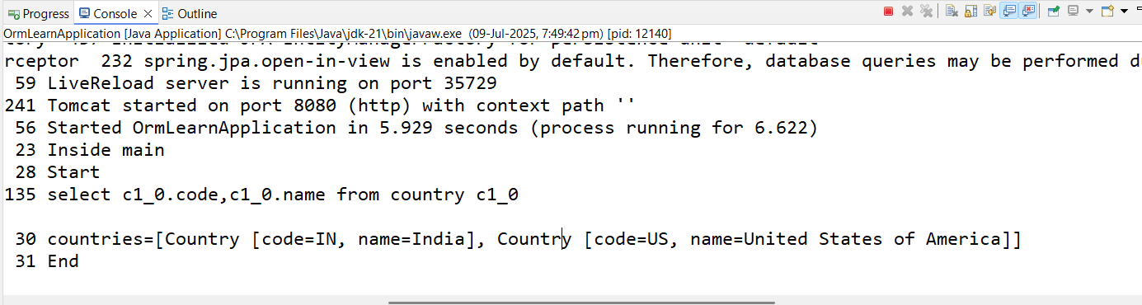

**Exercise 2: Difference between JPA, Hibernate and Spring Data JPA**

**Pom.xml :**

<?xml version="1.0" encoding="UTF-8"?>

<project xmlns="http://maven.apache.org/POM/4.0.0" xmlns:xsi="http://www.w3.org/2001/XMLSchema-instance"

xsi:schemaLocation="http://maven.apache.org/POM/4.0.0 https://maven.apache.org/xsd/maven-4.0.0.xsd">

<modelVersion>4.0.0</modelVersion>

<parent>

<groupId>org.springframework.boot</groupId>

<artifactId>spring-boot-starter-parent</artifactId>

<version>3.5.3</version>

<relativePath/> <!-- lookup parent from repository -->

</parent>

<groupId>com.example</groupId>

<artifactId>employee-app</artifactId>

<version>0.0.1-SNAPSHOT</version>

<name>employee-app</name>

<description>Demo project for Spring Boot</description>

<url/>

<licenses>

<license/>

</licenses>

<developers>

<developer/>

</developers>

<scm>

<connection/>

<developerConnection/>

<tag/>

<url/>

</scm>

<properties>

<java.version>17</java.version>

</properties>

<dependencies>

<dependency>

<groupId>org.springframework.boot</groupId>

<artifactId>spring-boot-starter-data-jpa</artifactId>

</dependency>

<dependency>

<groupId>org.springframework.boot</groupId>

<artifactId>spring-boot-starter-web</artifactId>

</dependency>

<dependency>

<groupId>com.mysql</groupId>

<artifactId>mysql-connector-j</artifactId>

<scope>runtime</scope>

</dependency>

<dependency>

<groupId>org.springframework.boot</groupId>

<artifactId>spring-boot-starter-test</artifactId>

<scope>test</scope>

</dependency>

</dependencies>

<build>

<plugins>

<plugin>

<groupId>org.springframework.boot</groupId>

<artifactId>spring-boot-maven-plugin</artifactId>

</plugin>

</plugins>

</build>

</project>

**EmployeeController.java :**

package com.example.employee_app.controller;

import com.example.employee_app.model.Employee;

import com.example.employee_app.service.EmployeeService;

import org.springframework.beans.factory.annotation.Autowired;

import org.springframework.web.bind.annotation.*;

@RestController

@RequestMapping("/employees")

public class EmployeeController {

@Autowired

private EmployeeService employeeService;

@PostMapping("/add")

public String addEmployee(@RequestBody Employee employee) {

employeeService.addEmployee(employee);

return "Employee saved successfully!";

}

@GetMapping("/test")

public String test() {

return "Test working!";

}

}

**EmployeeRepository.java :**

package com.example.employee_app.repository;

import com.example.employee_app.model.Employee;

import org.springframework.data.jpa.repository.JpaRepository;

public interface EmployeeRepository extends JpaRepository<Employee, Integer> {

}

**EmployeeService.java :**

package com.example.employee_app.service;

import com.example.employee_app.model.Employee;

import com.example.employee_app.repository.EmployeeRepository;

import org.springframework.beans.factory.annotation.Autowired;

import org.springframework.stereotype.Service;

import org.springframework.transaction.annotation.Transactional;

@Service

public class EmployeeService {

@Autowired

private EmployeeRepository employeeRepository;

@Transactional

public void addEmployee(Employee employee) {

employeeRepository.save(employee);

}

}

**EmployeeAppApplication.java :**

package com.example.employee_app;

import org.springframework.boot.SpringApplication;

import org.springframework.boot.autoconfigure.SpringBootApplication;

@SpringBootApplication

public class EmployeeAppApplication {

public static void main(String[] args) {

SpringApplication.run(EmployeeAppApplication.class, args);

}

}

**Output :**

